DIS-INDO-NIAS-Uma Figure-35in.

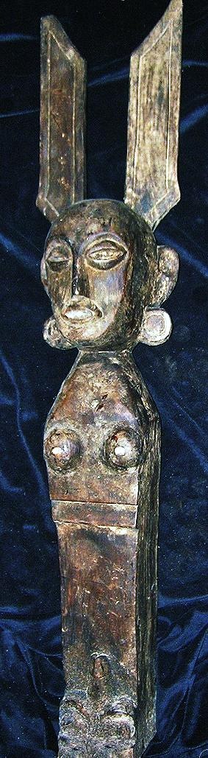 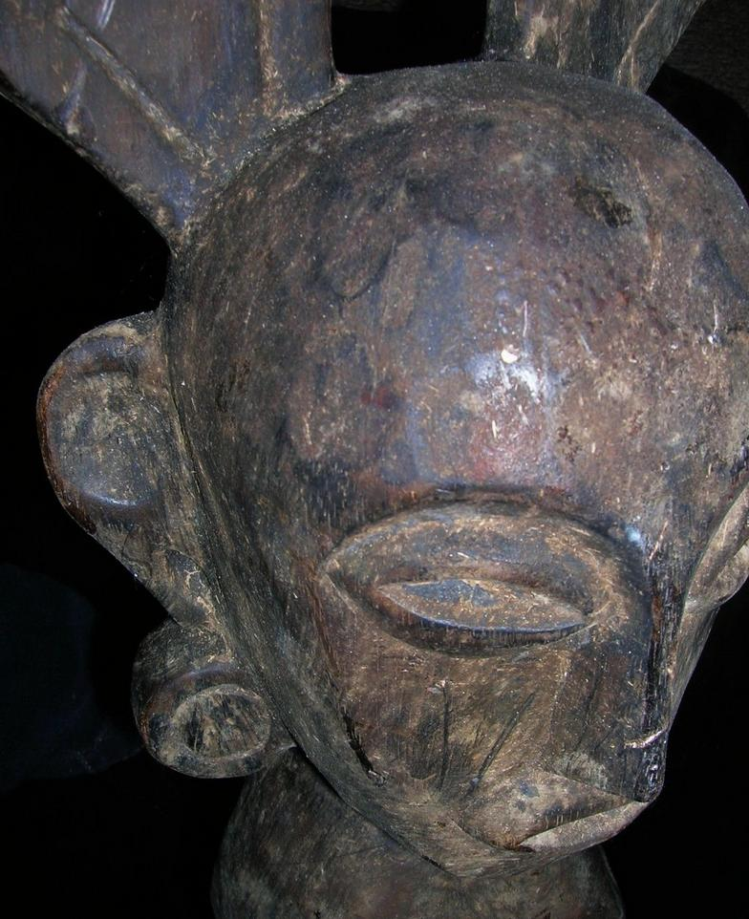

Nias Uma Ancestress figure, 35 in. tall, dating to ca 1910, exhibiting many years of ceremonial use in the worship of women ancestors. In this sculpted specimen note the feather headdress and the elongated ears and ear spools indicating tribal rank. Ex The Bouck Estate, New York City, 2014.

Nīas (Indonesian: *Pulau Nias*, Nias language: Tanö Niha) is an island off the southwestern coast of Sumatra, Indonesia, covering an area of 5,121.3 km.2 (1,977.3 sq. mi.). It is mostly a lowland area rising to around 800 m. (2,600 ft.) above sea level. It was first inhabited by Paleolithic Hoabinians but then later ca. 2000 BCE waves of Austronesians settled the island.

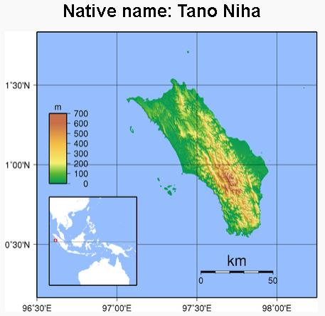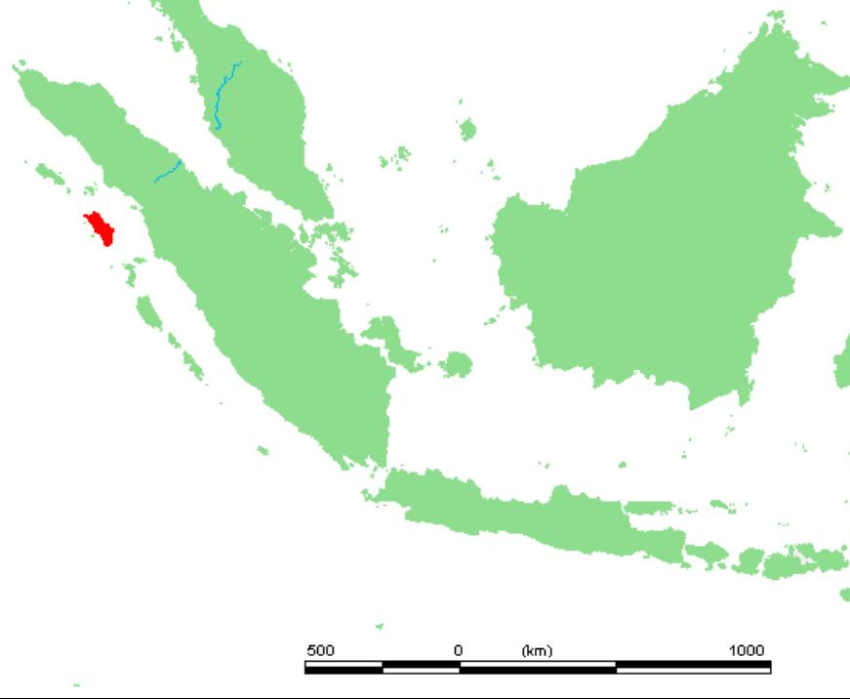

**Nias, Coordinates** [1°6′N 97°32′E](https://tools.wmflabs.org/geohack/geohack.php?pagename=Nias&params=1_6_N_97_32_E_type:isle_scale:2500000)

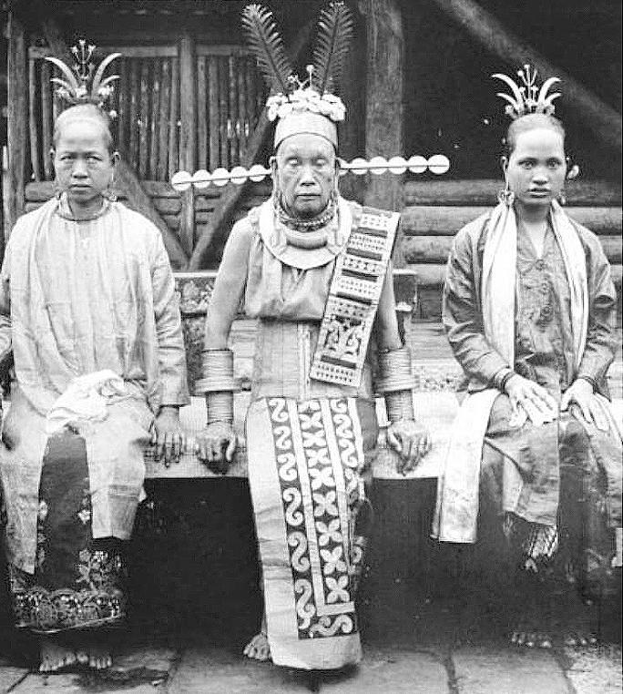An aged Nias princess with her4 daughters showing an Uma headdress, similar to that in our specimen. Notice, in addition to the headdress, the princess also exhibits elongated ears and ear spools as do her two daughters. Photograph in the Museum Volkenkunde Museum Volkenkunde, Africa Museum, in Amsterdam. Photograph made by Christiaan Benjamin Nieuwenhuis (1863-1922) ca. 1918.

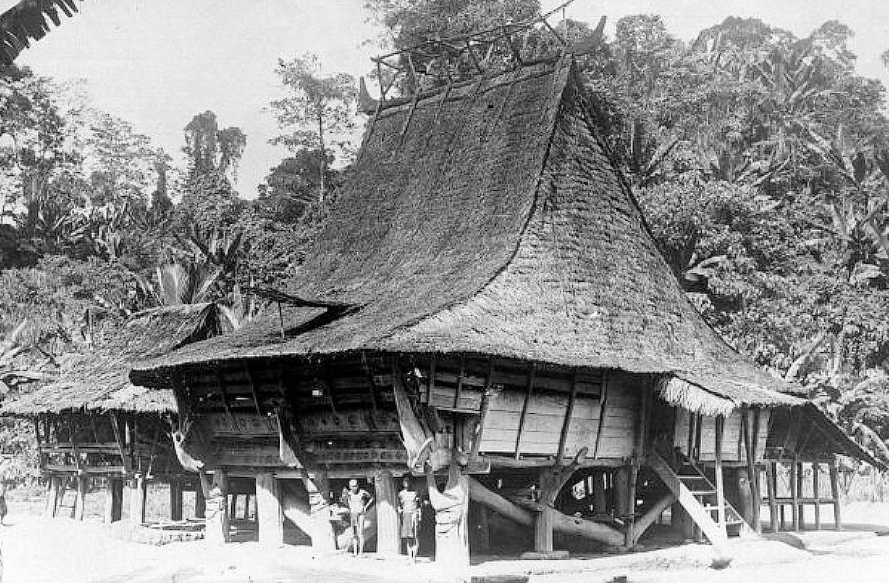

Detail of a Nias men's house. Photograph in the Museum Volkenkunde Museum Volkenkunde, Africa Museum, in Amsterdam. Photograph made by Christiaan Benjamin Nieuwenhuis (1863-1922) ca. 1918.

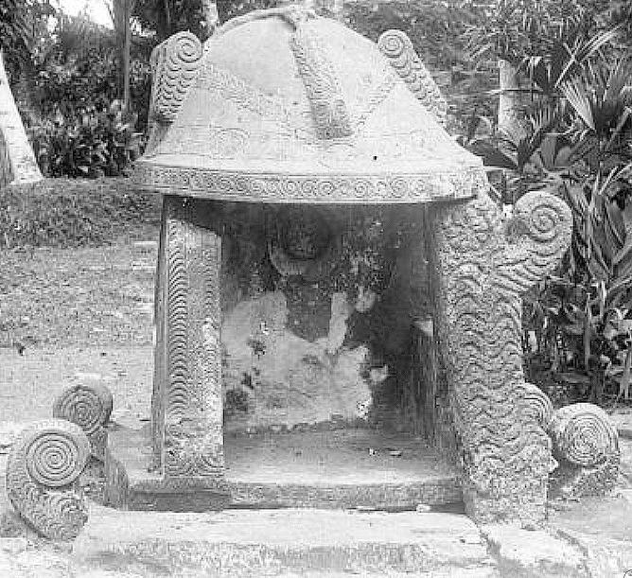

Detail of a Nias sacrificial alter. Photograph in the Museum Volkenkunde Museum Volkenkunde, Africa Museum, in Amsterdam. Photograph made by Christiaan Benjamin Nieuwenhuis (1863-1922) ca. 1918.

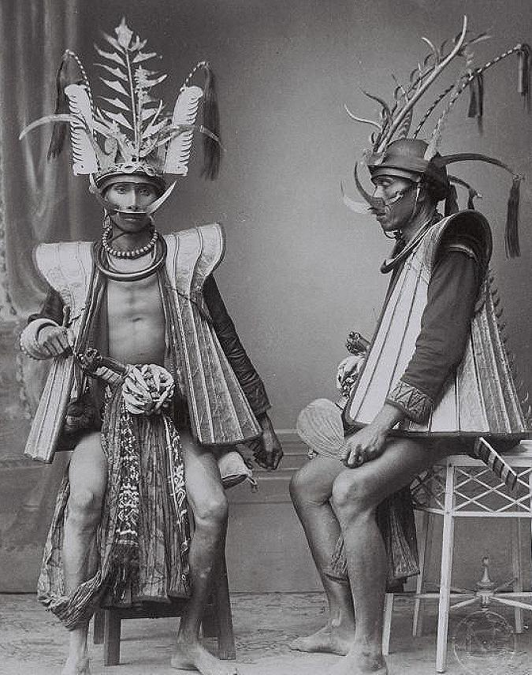

Detail of a photograph of South Nias warriors in full regalia. Photograph in the Museum Volkenkunde Museum Volkenkunde, Africa Museum, in Amsterdam. Photograph made by Christiaan Benjamin Nieuwenhuis (1863-1922) ca. 1918.

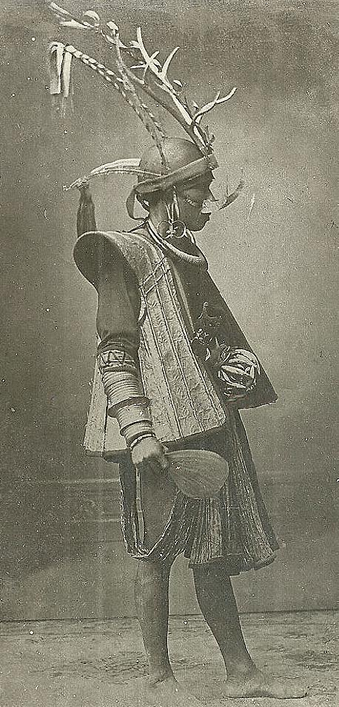

Detail of a photograph of South Nias warrior seated to the right in the previous photo in full regalia: Photograph made by Christiaan Benjamin Nieuwenhuis (1863-1922) ca. 1918.

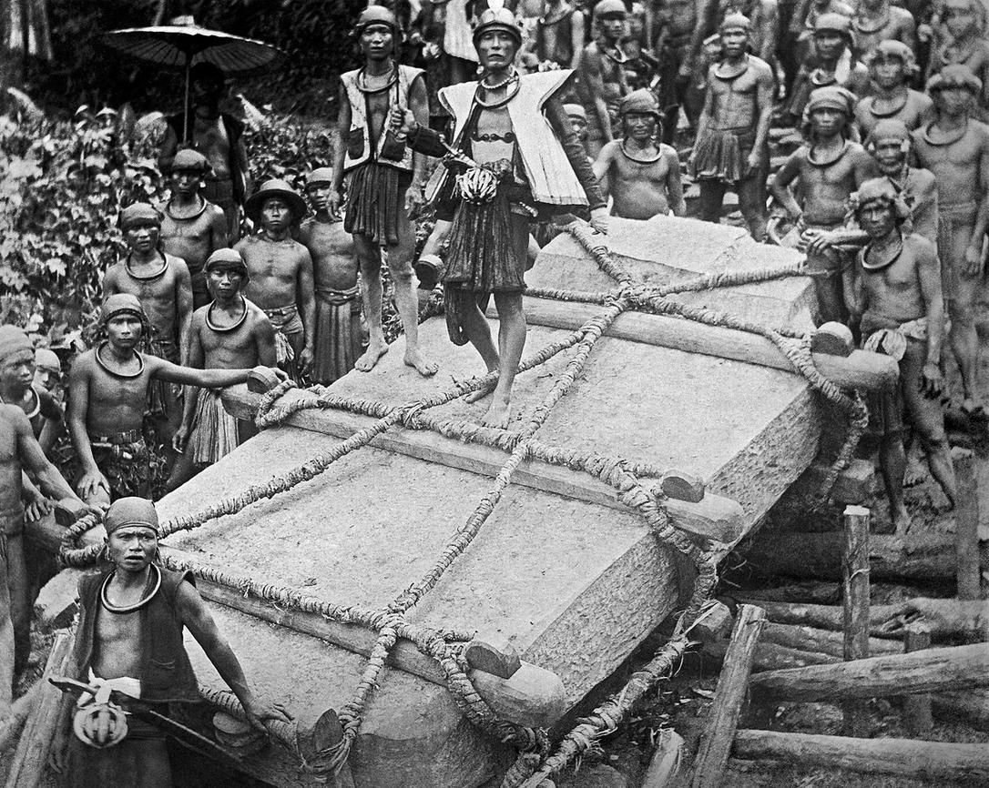

Villagers in Bawomataluo on Nias move a megalith blank for sculpturing around 1915. In the photo a megalith is hauled by 525 people three days to erect it in the village of Bawemataloeo. (P. Boomgaard, 1981). .. Detail of a photograph in the Museum Volkenkunde, Africa Museum, in Amsterdam

Nias megaliths, often decorated, were accompanied by stone seats for the chieftains and stone tables where justice enacted, as well as stone statuary commemorating the deceased. When such a megalith was erected, a ritual feast was given in order for relatives to join the godly ancestor in the afterlife.

### Delivery package 1 of 1

Estimated delivery Friday, Oct 9, 2015 - Tuesday, Oct 13, 2015

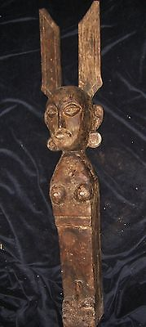

#### [NIAS UMA FIGURE 35"](http://www.ebay.com/itm/221898123140)

|  |  |
| --- | --- |
| Item price | $89.99 |
| Quantity | 1 |
| Item number | 221898123140 |
| Shipping service | USPS Priority Mail |

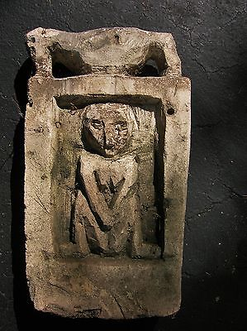

#### [DAYAK STONE PROTECTIVE FIGURE 15"](http://www.ebay.com/itm/221898141111)

|  |  |
| --- | --- |
| Item price | $79.99 |
| Quantity | 1 |
| Item number | 221898141111 |
| Shipping service | USPS Priority Mail |